WEEK 2 2520030080
N. Greeshma
Aim:
To implement SQL concepts such as JOIN, GROUP BY, Transactions, and Indexing in a library database.

Step – 1 : Create Database :
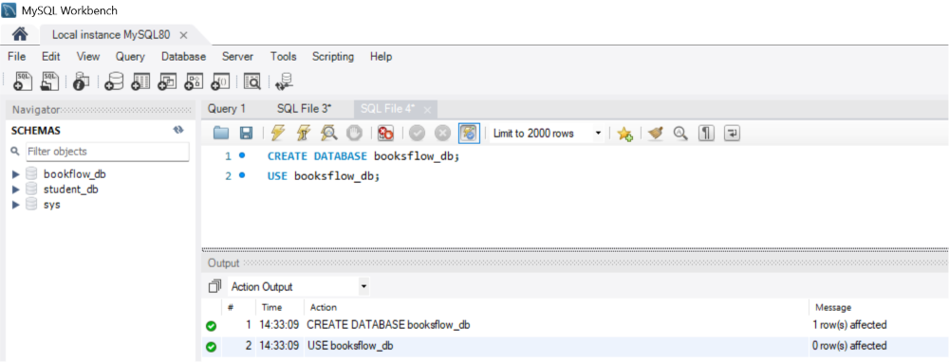
Step 2 — Create Books Table (DDL + Constraints) :
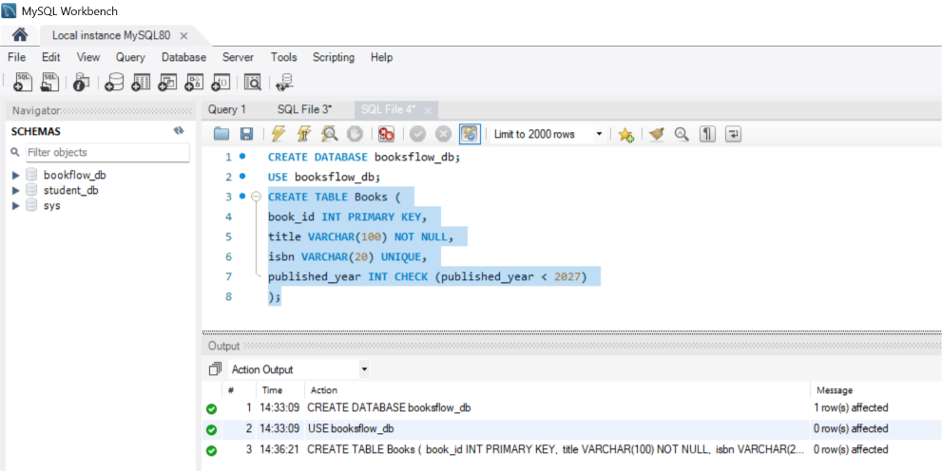

Step 3 - Insert Books :
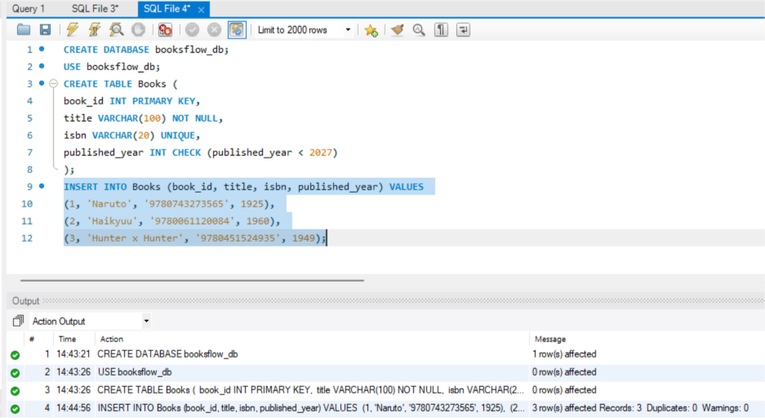
Step 4 – Display :
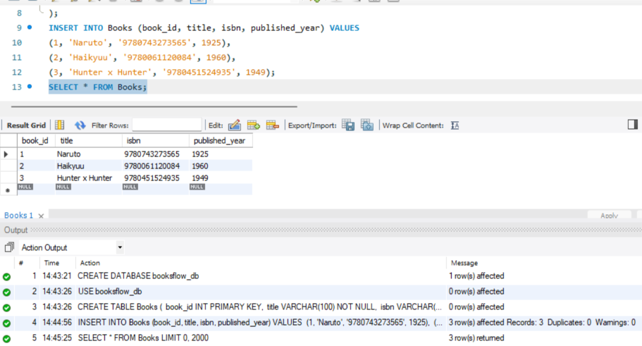

Step 5 - Members Table :-
Create :
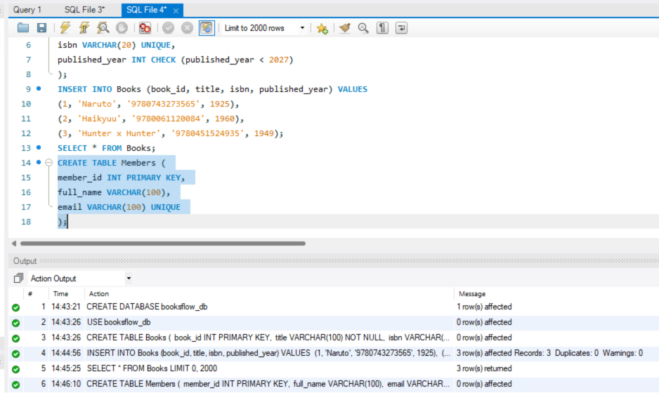
Insert :
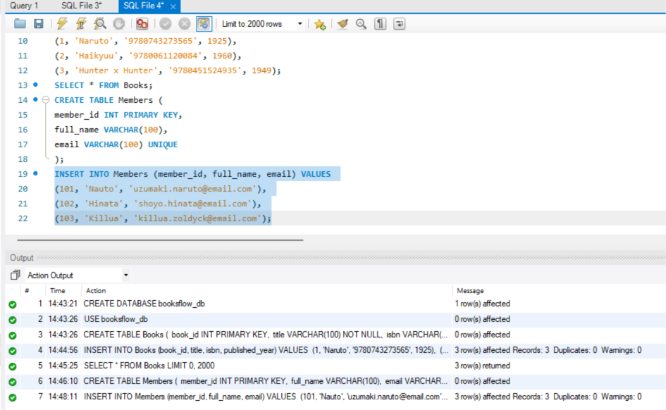

Display :
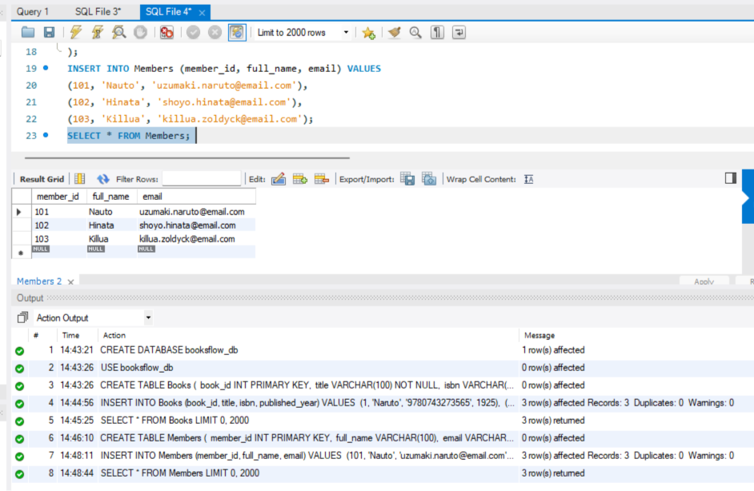
Step 6 - Create Loans Table (FOREIGN KEYS):
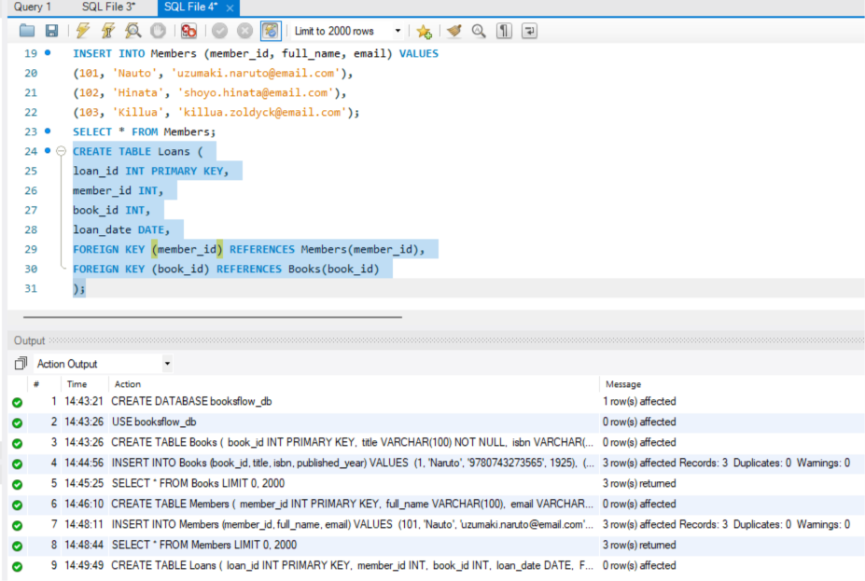

Step 7 - Insert 10 Loans :
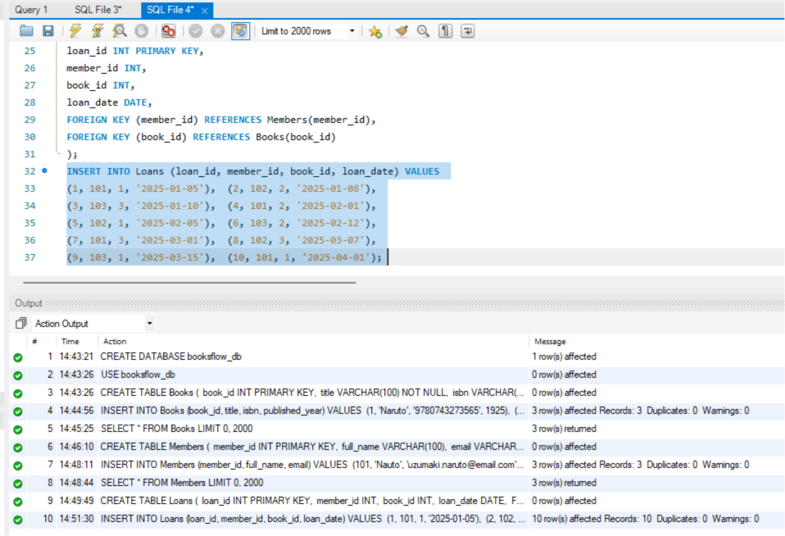
Step 8 – Display :
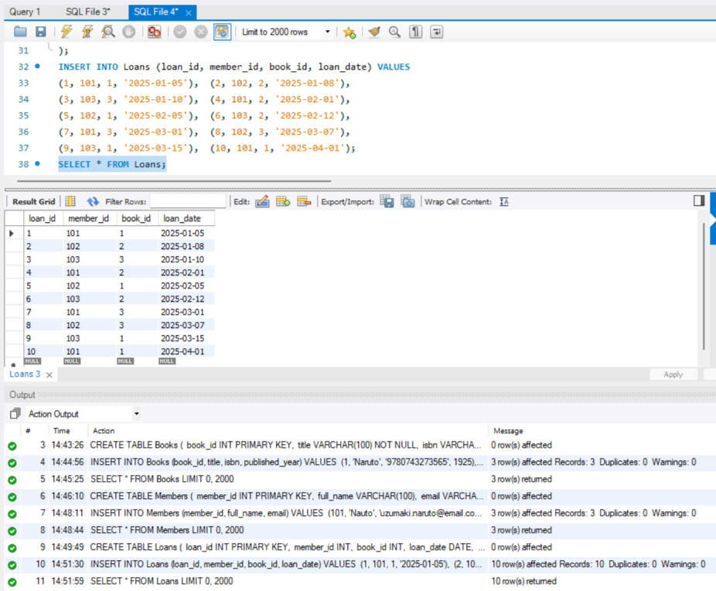
Step 9 - JOIN Query (Who Borrowed What):
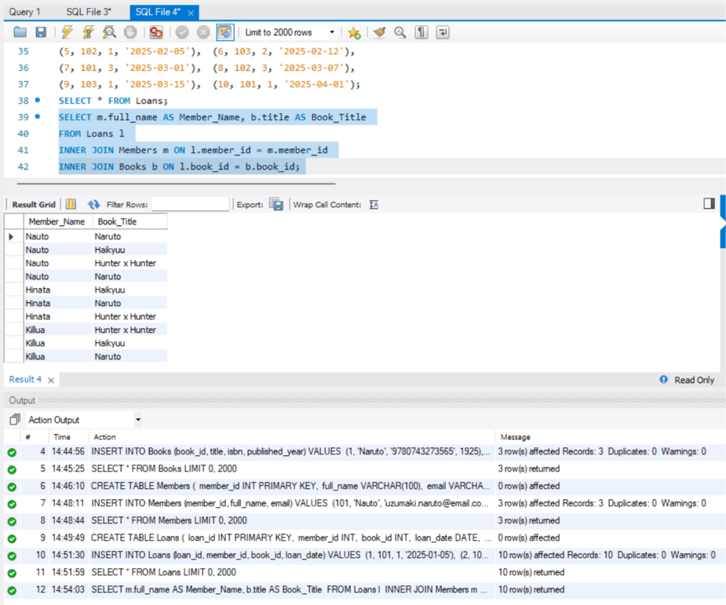
Step 10 - GROUP BY Query (Books per Year):
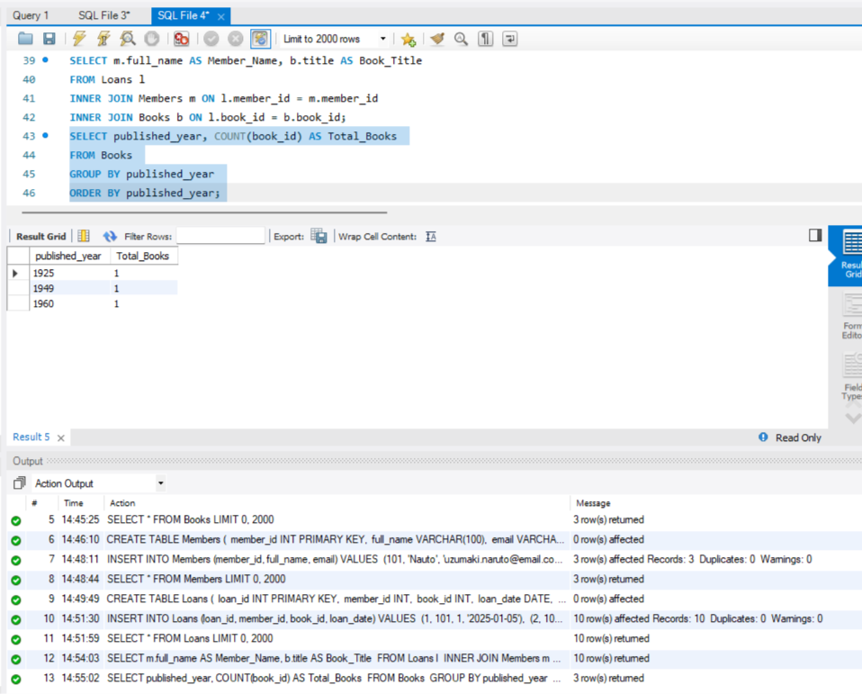
Step 11 - Donation via TRANSACTION (Atomicity) :
Create :
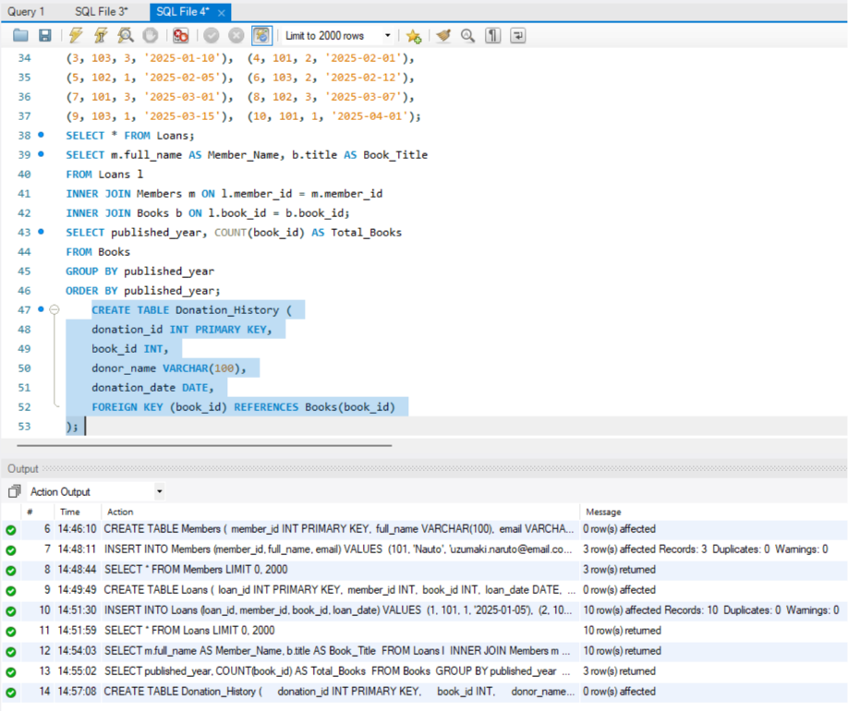
Insert & Commit:
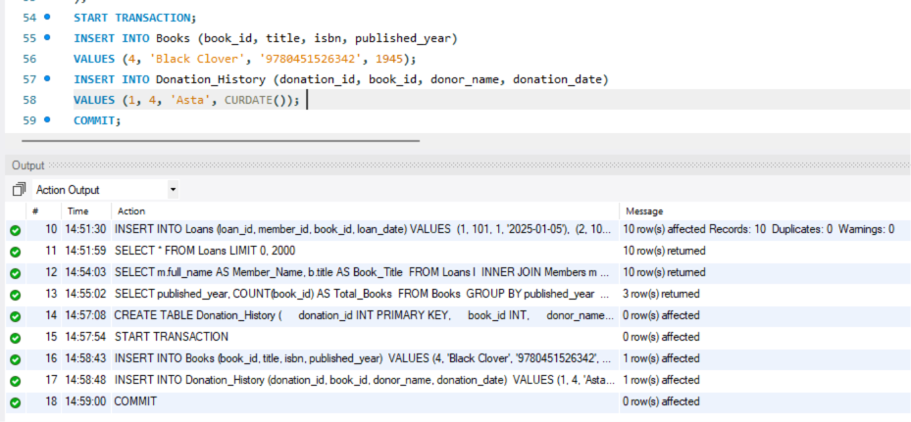

Step 12 - Index on ISBN + Fast Search :
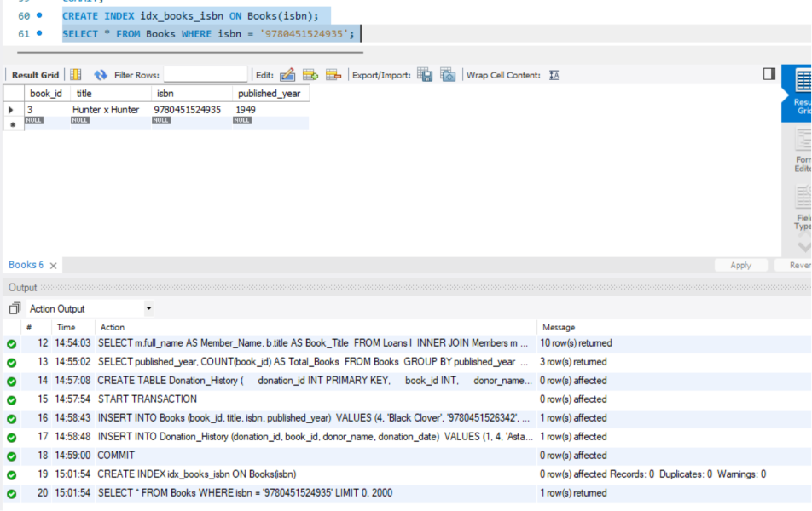
Conclusion :
This project successfully demonstrates the implementation of a Library Management Database using SQL. It covers essential database concepts such as creating databases and tables, applying constraints (Primary Key, Foreign Key, Unique, and Check), inserting and retrieving data, performing JOIN and GROUP BY operations, managing transactions with COMMIT, and improving query performance using indexing. The database ensures data integrity, maintains relationships between books, members, loans, and donations, and provides an efficient way to manage library records.

